Green Society Public School
D-22
Ratnanagar-7, Sauraha, Chitwan
Third Terminal Examination-2082
Class: UKG Time: - 2 hrs. F.M.: 50
Sub: Social Science
Name: Roll No.: Sec.:
________________ ______________ OBT.MARKS:
INVIGILATOR EXAMINER
- Write the name of the flower. (3)

- Name of sports. (3)

- Write the name of vegetable. (3)

- write the name of weather. (3)

- Write the name of product which we get from animal. (4)
Hen =
Cow =
Sheep =
Goat =
- Name of the given picture. (4)
 | 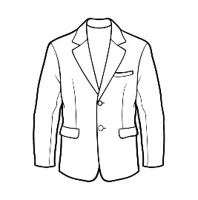 | 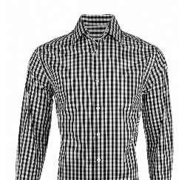 | 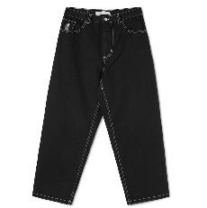
- Write 'good' and 'bad'. (5)
- Helping Friend
- Fighting with friends.
- Cutting Nails.
- Playing on road.
- Brushing teeth.
- Fill in the Blanks. (5)
- Our national animal is ………………..(cow, Dog).
- Our national Bird is……………………………………( Lophophorus, Parrot).
- Our National flower is…………………………………(Rhododendron, Lily)
- Our National colour is ……………………………..(Crimson, yellow)
- Our national weapon is ……………………………(Khukuri, Knife)

- Match the following. (animals with their baby) (6)
Dog kitten
cat puppy
sheep piglet
Goat Cub
Tiger kid
- Write healthy and unhealthy food. (6)
Rice Noodles egg meat drinks sugar

Healthy | Unhealthy

- Write the name of parts of plant. (7)
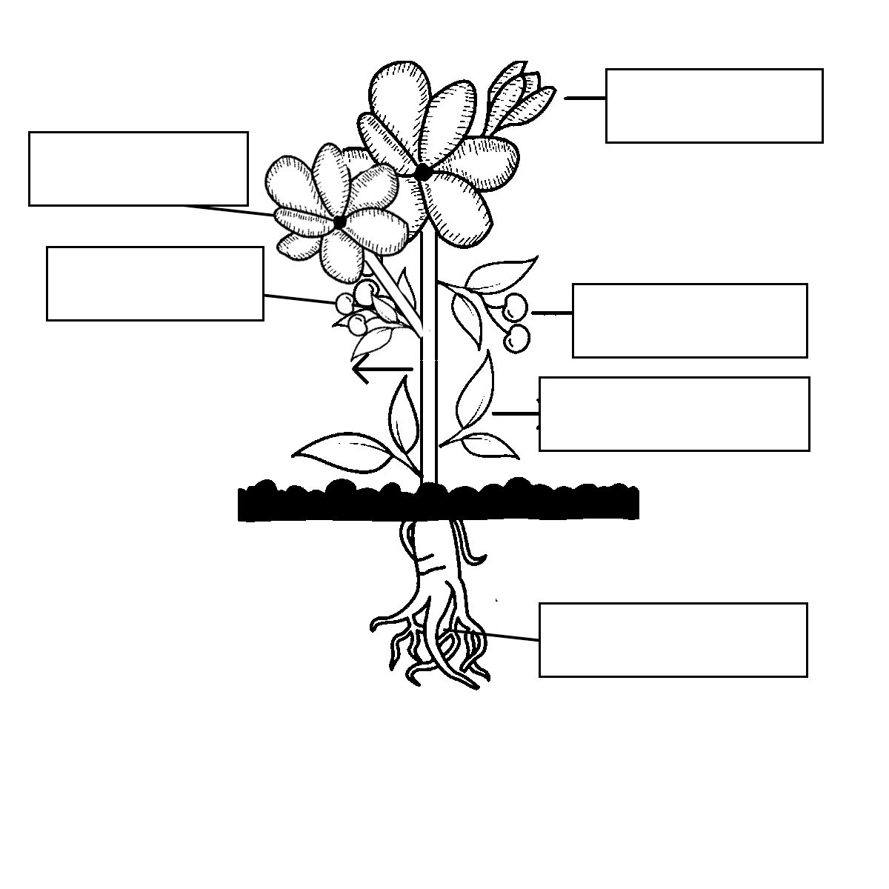

The End

